Basic concept of web

Web page- Single page means web page.

Web Site

Web Site - Combination of many web page.

Example: facebook

Domain

Our website name is domain.

Hosting

Space of the website content.

Web request

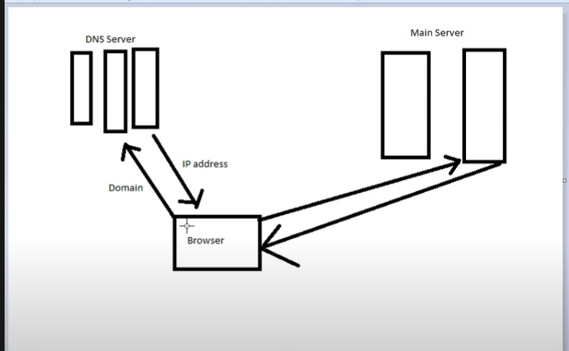

URL(Domain name) : Uniform resource locator

https://www.facebook.com

<http://www.atovait.com>

1. HTTPS/HTTP
2. www
3. other

HTTPS/HTTP

HTTP: Hypertext transfer protocol

HTTPS: Hypertext transfer protocol secure

Protocol: Protocol means rule

Hypertext: hypertext means website text

www

www- world wide web

other

other- Our name

HTML

HTML : Hypertext markup language

Markup- Specific

Css

CSS- Cascading style sheets

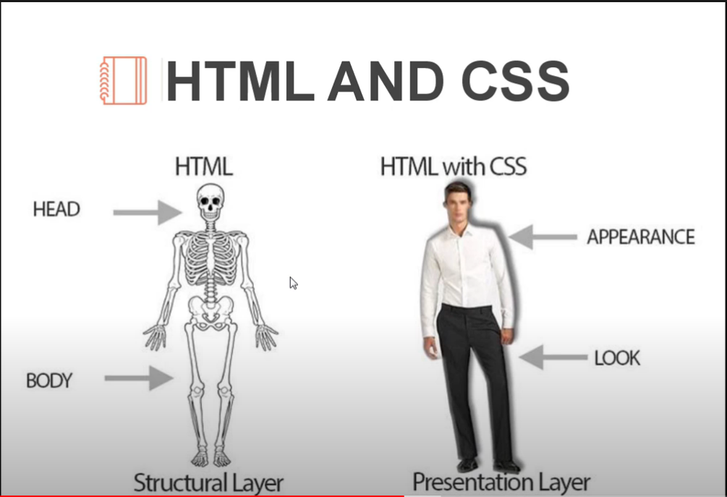

JS

JS: JavaScript

PHP

PHP- Hypertext Preprocessor

Data base- mysql

